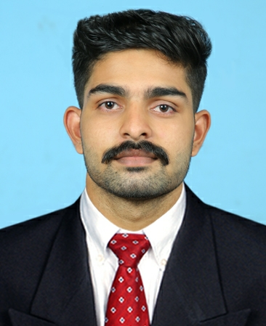
DIBIN DAVIS
Thoppil House
Potta P.O, Thrissur Dt
Kerala-680722
Email :- dibindavis021@gmail.com
Mob No: 9400280787

OBJECTIVE:
In pursuit of a career where I can utilize my technical skills and managerial abilities and to keep learning , move along to have a constructive influence in the progress and advancement of the organization.
EDUCATIONAL QUALIFICATION:

INSTITUTE | COURSE | YEAR OF PASS | PERCENTAGE | CGPA
ST. MARY’S POLYTECHNIC COLLEGE, PALAKKAD | DIPLOMA IN AUTOMOBILE ENGINEERING | 2019 |  | 7.76
S.N.V.H.S.S, ALOOR | PLUS TWO | 2016 | 68
L.F.C.H.S.S, KORATTY | SSLC | 2014 | 73

AREAS OF EXPERTISE
- AutoCAD 2D&3D (Mechanical)
AREA OF INTERESTING
- Riding bike, Travelling

PERSONAL QUALITIES

Highly motivated influencing skills and dynamic , trusty and reliable.
PROFESSIONAL EXPERIENCE
UNITED MOTORS AND HEAVY EQUIPMENT CO. (L.L.C) (BR)(MAN), UAE.
Designation: Mechanic Assistant.
Duration: 09-11-2025 To Present
Key Responsibilities:
Assisting with vehicle inspections and diagnostics, helping repair or replace faulty parts, and performing routine maintenance like oil changes and brake checks. Supporting workshop operations by handling tools, maintaining clean workspaces, and assisting during installations. Continuously learning repair techniques through training while following safety rules and properly handling hazardous materials.

Autobahn trucking Bharat Benz Aluva Br., Kerala.
Designation: Assi. Technician
Duration: 26-10-2021 To 05-08-2025
Key Responsibilities:

1. Assisting with Diagnostics and Repairs
- Helping perform vehicle inspections to identify issues.
- Using diagnostic tools to pinpoint mechanical or electrical problems.
- Assisting in repairing or replacing faulty components like brakes, engines, or transmission systems.

2. Routine Maintenance Tasks
- Conducting oil changes, tire rotations, and brake checks.
- Replacing filters (air, fuel, and oil filters).
- Checking fluid levels and topping them off as needed.

3. Equipment and Tool Handling
- Organizing and maintaining tools and equipment.
- Cleaning and preparing workspaces for repairs.
- Assisting in lifting or holding parts during installations.

4. Learning and Development
- Observing and learning advanced repair techniques.
- Participating in on-the-job training sessions.
- Staying updated on vehicle technologies and repair practices.

5. Safety and Compliance
- Following workplace safety protocols and guidelines.
- Disposing of hazardous materials properly (e.g., oil, batteries).
Friends auto garage, potta, chalakudy (Gov. APPROVED)
Designation: Automobile Mechanic
Duration: 20-07-2019 To 6-8-2021
Here my role is to be diagnosing, repairing, and maintaining vehicles to ensure safety and optimal performance. My duties include identifying issues using diagnostic tools, repairing or replacing faulty components, and performing routine maintenance such as oil changes, tire rotations, and brake checks.

ACHIEVEMENTS
- Highest Labour in 6 months at Autobahn trucking Bharat Benz
PROJECTS AND SEMINAR
- AIR BRAKE SYSTEM
- CUT SECTION OF POWER TRANSMISSION SYSTEM
- SEMINAR - AUTOMATED HIGHWAY SYSTEM

PERSONAL PROFILE:

Father’s Name : DAVIS T A

Mother’s Name : SHERLY DAVIS

Date Of Birth : 20-03-1999

Gender : Male

Marital Status : Single

Nationality : Indian

Languages Known : English, Malayalam

Passport Number : X3685051

Place of Issue : COCHIN

Date of Issue : 02/02/2024

Date of Expiry : 01/02/2034

REFERENCES

NAME | CONTACT NUMBER | DESIGNATION
Vinod | 94002 40347 | Floor Supervisor, Autobahn trucking bharatbenz Aluva Br. ,Kerala.
Pranav E S | 99611 33544 | Floor Supervisor, Autobahn trucking bharatbenz Aluva Br. ,Kerala

I do hereby declare that all statements made above are true to the best of my knowledge and belief.
Place: POTTA DIBIN DAVIS
Date:

